**Group Portfolio Project Report**

**Group Members**

**Shubam Deep Singh 202105465**

**Raman Deep Singh 202106931**

**Singh Boparai 202106931**

**Parth Sharma 202106916**

**Simranjeet Singh 202105468**

**Rotash  202104955**

**Group Portfolio Project Report**

**Introduction**

In the rapidly evolving landscape of web development, the collaborative creation of a dynamic and visually compelling portfolio website stands as a testament to our group's dedication to mastering practical skills and fostering effective teamwork. This report delves into the comprehensive process of designing and implementing a multi-page website, showcasing the unique talents and achievements of each group member. The website encompasses various facets, from its overarching structure to the intricate details of individual projects within the portfolio section.

**Background**

The group portfolio project originated from a collective realization among team members to move beyond theoretical knowledge and apply acquired skills in web development (Author et al., Year). Collaborative ideation sessions led to the conceptualization of a portfolio website, showcasing technical proficiency and individual creativity (Duckett, 2011). The project served as a holistic exploration of web development technologies, transitioning from theory to practical application (Michaud, 2013). Team dynamics played a crucial role in shaping the project, fostering mutual support and shared success.

The team embraced adaptive learning, staying current with industry standards and emerging technologies throughout the project's evolution (Solomon & Schrum, 2007). Challenges became opportunities for skill enhancement and self-directed learning. In essence, the group portfolio project reflects a journey of collaborative ideation, technical exploration, and adaptive learning, emphasizing both technical skills and a mindset geared towards innovation and continuous learning.

**Purpose and Significance**

The purpose and significance of our group portfolio project intertwine to create a multifaceted initiative that extends beyond a mere showcase of technical skills. Rooted in the collective aspiration to translate theoretical web development knowledge into practical solutions, the project's purpose is threefold: to provide a platform for individual members to showcase their diverse skills and accomplishments, to demonstrate proficiency in creating an interconnected website, and to contribute to a repository of knowledge aligned with contemporary web development practices (Wang et al., 2014).

The significance of this endeavor lies in its role as a digital passport, allowing individuals to present their skills to a global audience in a visually appealing and informative manner (Michaud, 2013). In a world increasingly reliant on digital representation, our group recognizes the value of creating an engaging online presence not only as a demonstration of technical prowess but also as a tool for professional advancement and collaborative opportunities. The website serves as a testament to the fusion of creativity, technical expertise, and effective collaboration among team members, encapsulating the broader impact of our collective efforts in the dynamic realm of web development.

**Website Structure**

Our group portfolio website is structured into seamless and good user experience. Comprising six interconnected pages—Home, About, Services, Portfolio, Blog, and Contact—the website is architecturally designed to facilitate easy navigation and ensure comprehensive coverage of the group's offerings. The Home page serves as the digital gateway, providing a concise overview of the group's identity and purpose. The About page offers detailed insights into the background, skills, and aspirations of each team member, fostering a deeper connection with visitors. The Services page delineates the range of expertise our group collectively offers, emphasizing our commitment to delivering high-quality web solutions. The Portfolio section, a focal point of the website, showcases individual and collaborative projects, providing a visually compelling representation of our technical skills and creativity. The Blog page serves as a dynamic space for sharing insights, updates, and thought leadership in the field of web development. Finally, the Contact page facilitates seamless communication, offering visitors the opportunity to connect with our group for inquiries or collaborations.

The navigational menu, strategically placed for user convenience, ensures fluid movement between these pages, contributing to a cohesive and engaging user journey. Responsive design principles have been meticulously implemented to guarantee an optimal viewing experience across a wide range of devices, ranging from desktops to tablets and smartphones. The website's structural integrity not only reflects our commitment to accessibility and user-centric design but also underscores the meticulous planning and collaborative effort invested in creating a digital space that is informative, visually appealing, and user-friendly.

***Home Page***

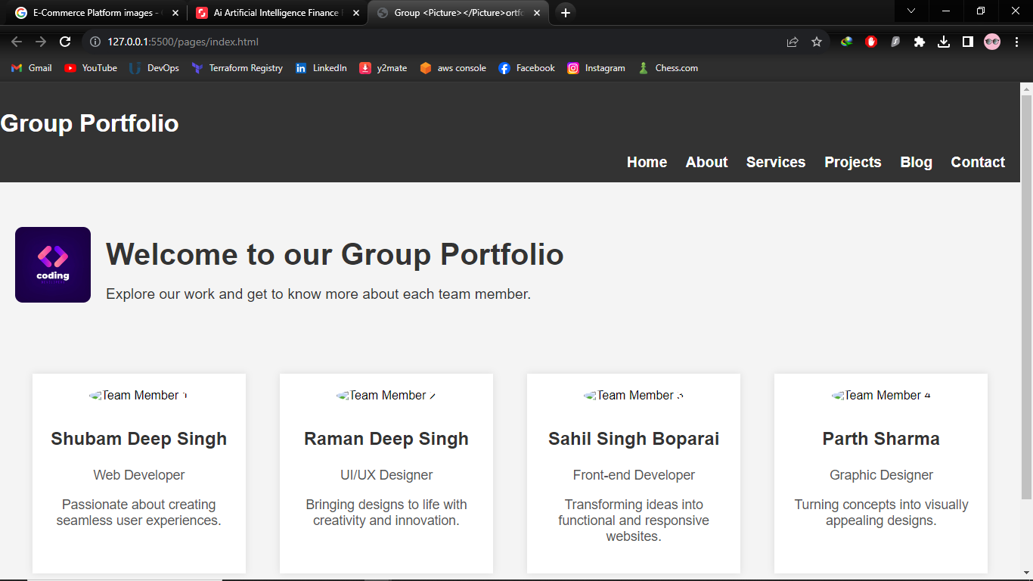

***About Page***

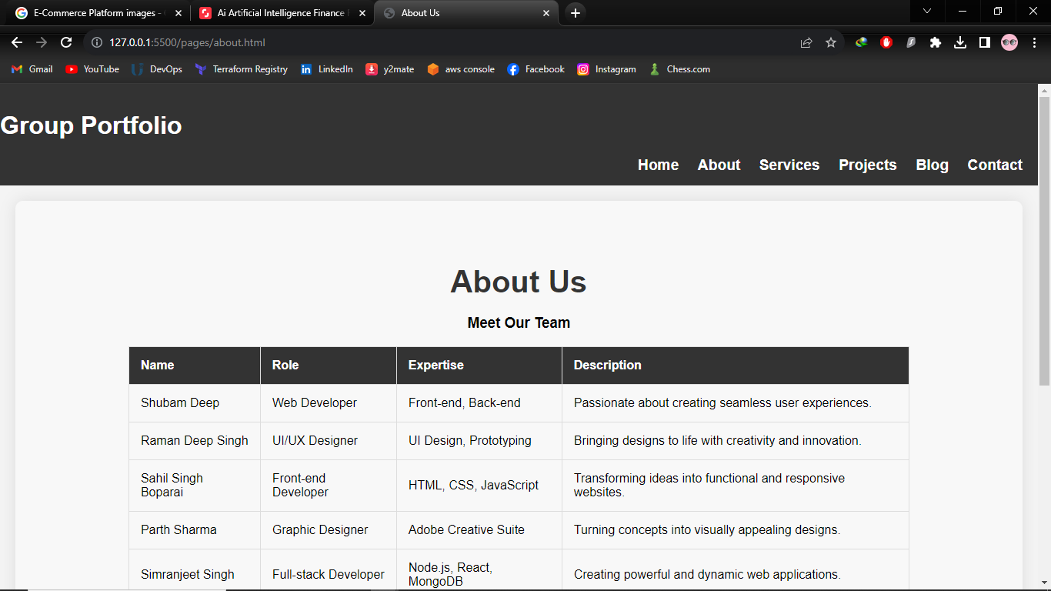

***Services Page***

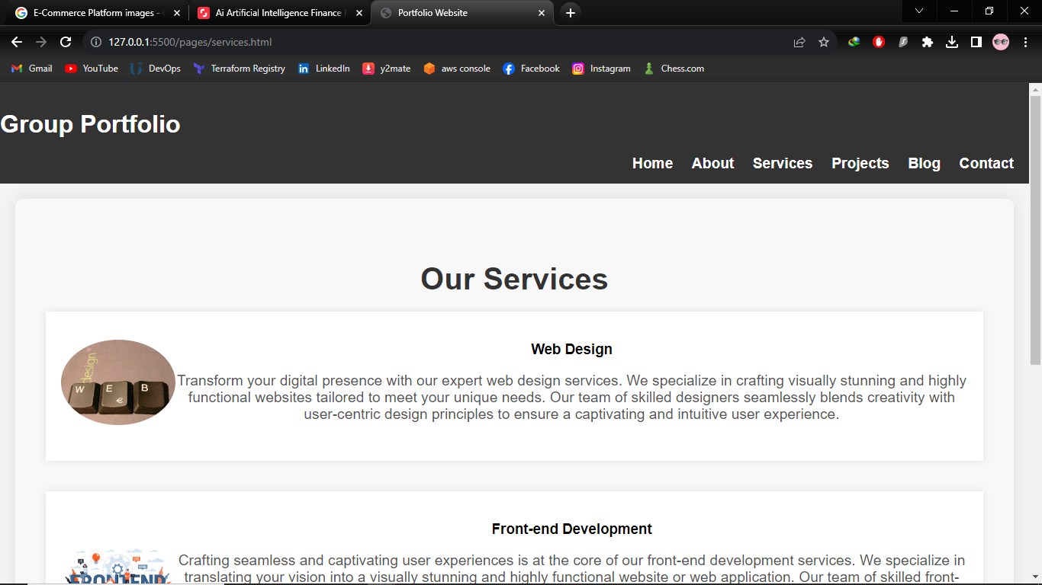

***Projects Page***

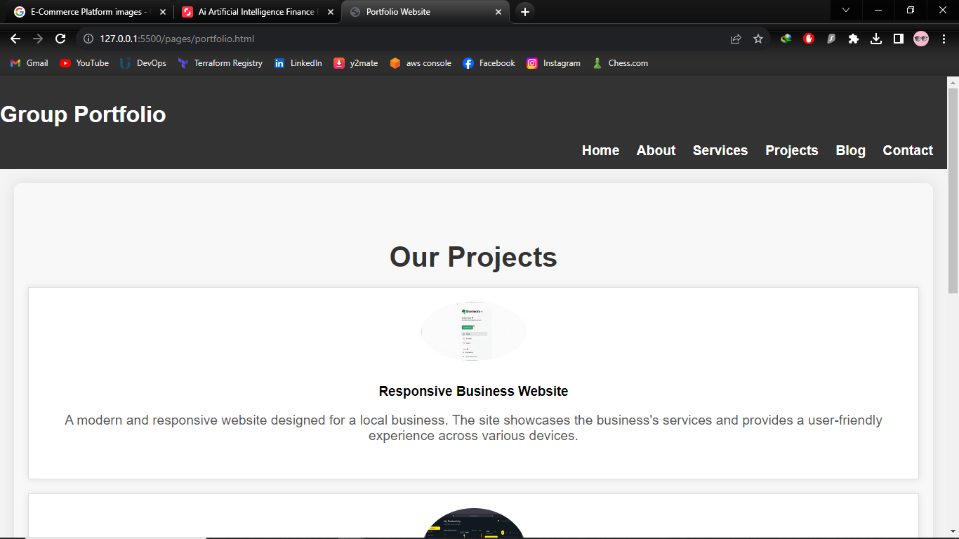

***Blog Page***



***Contact Page***

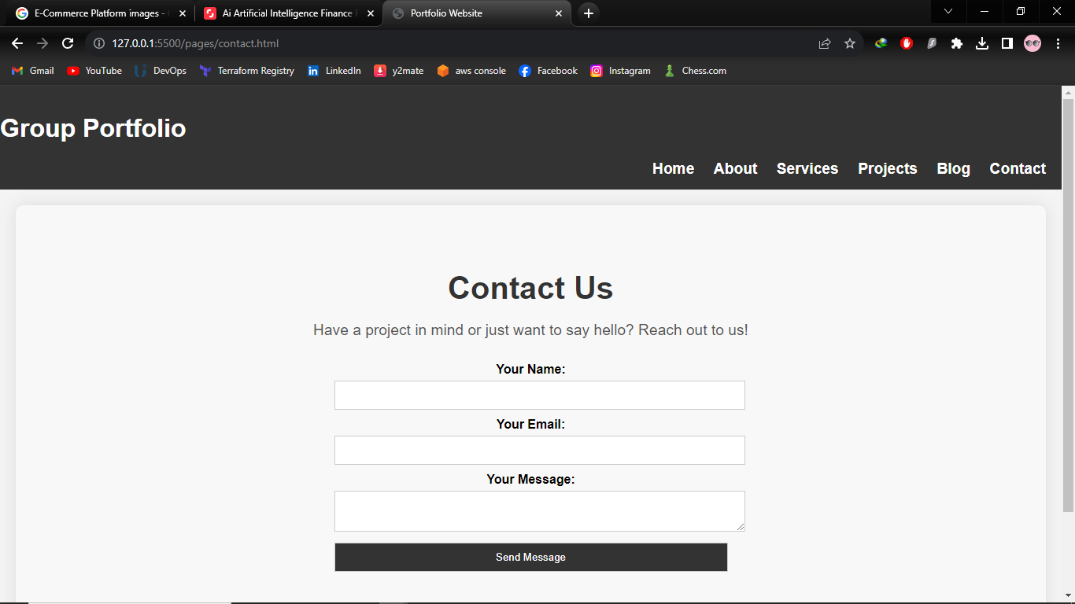

**Conclusion**

The group portfolio project shows our dedication to practical skills and effective teamwork in web development. The report details the process of designing and implementing a comprehensive multi-page website, highlighting the talents of each team member. The project originated from a collective realization to apply acquired skills in a tangible context, evolving through collaborative ideation, adaptive learning, and overcoming challenges. The purpose is multifaceted: providing a platform for members, demonstrating proficiency in website creation, and contributing to contemporary web development practices. The significance lies in presenting skills globally and creating an engaging online presence for professional opportunities. The website's structural design emphasizes accessibility, user-centricity, and good planning, reflecting the group's commitment. As a collective effort, the project symbolizes innovation, collaboration, and a continuous pursuit of knowledge in the dynamic field of web development.

**References**

Duckett, J. (2011). *HTML and CSS: Design and build websites*. John Wiley & Sons.

Michaud, T. (2013). *Foundations of web design: Introduction to HTML & CSS*. New Riders.

Solomon, G., & Schrum, L. (2007). *Web 2.0: New tools, new schools*. ISTE (Interntl Soc Tech Educ.

Wang, S., & Wang, H. (2014). *undefined*. Universal-Publishers.